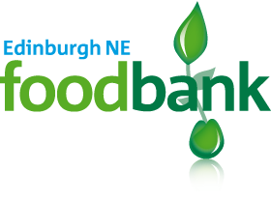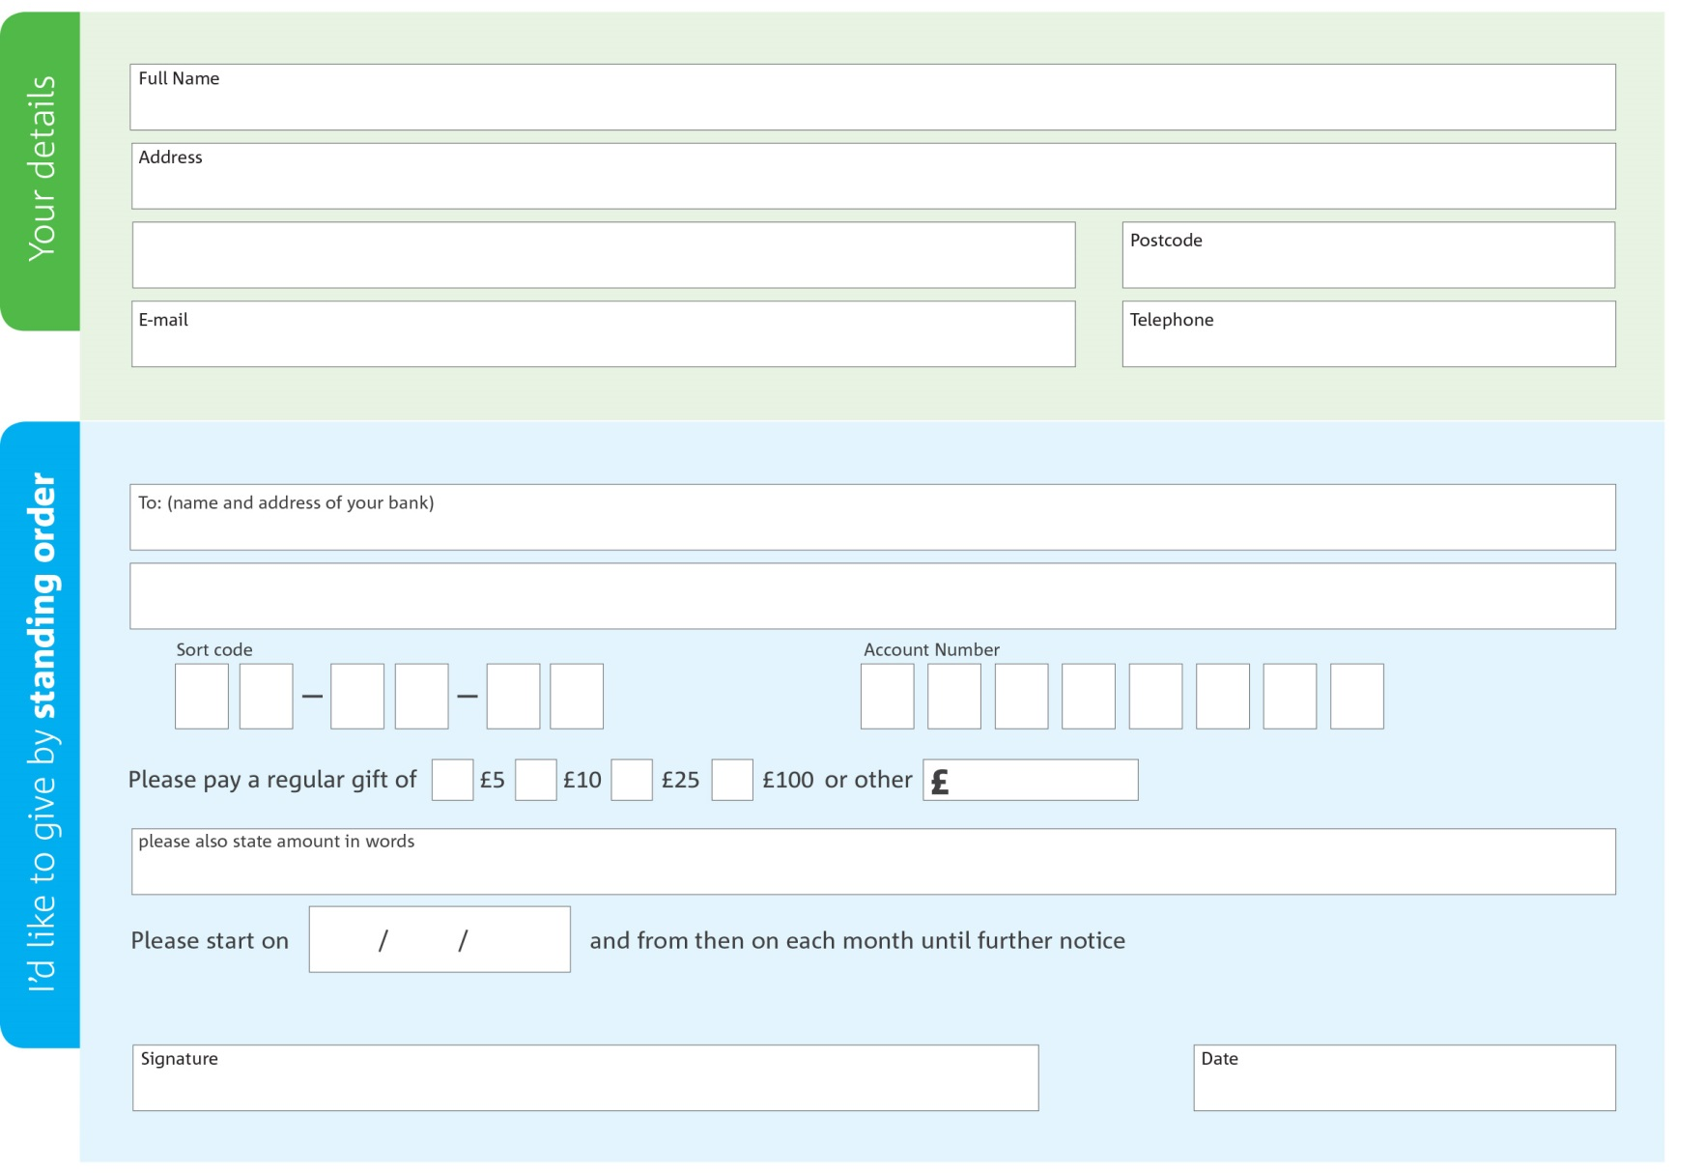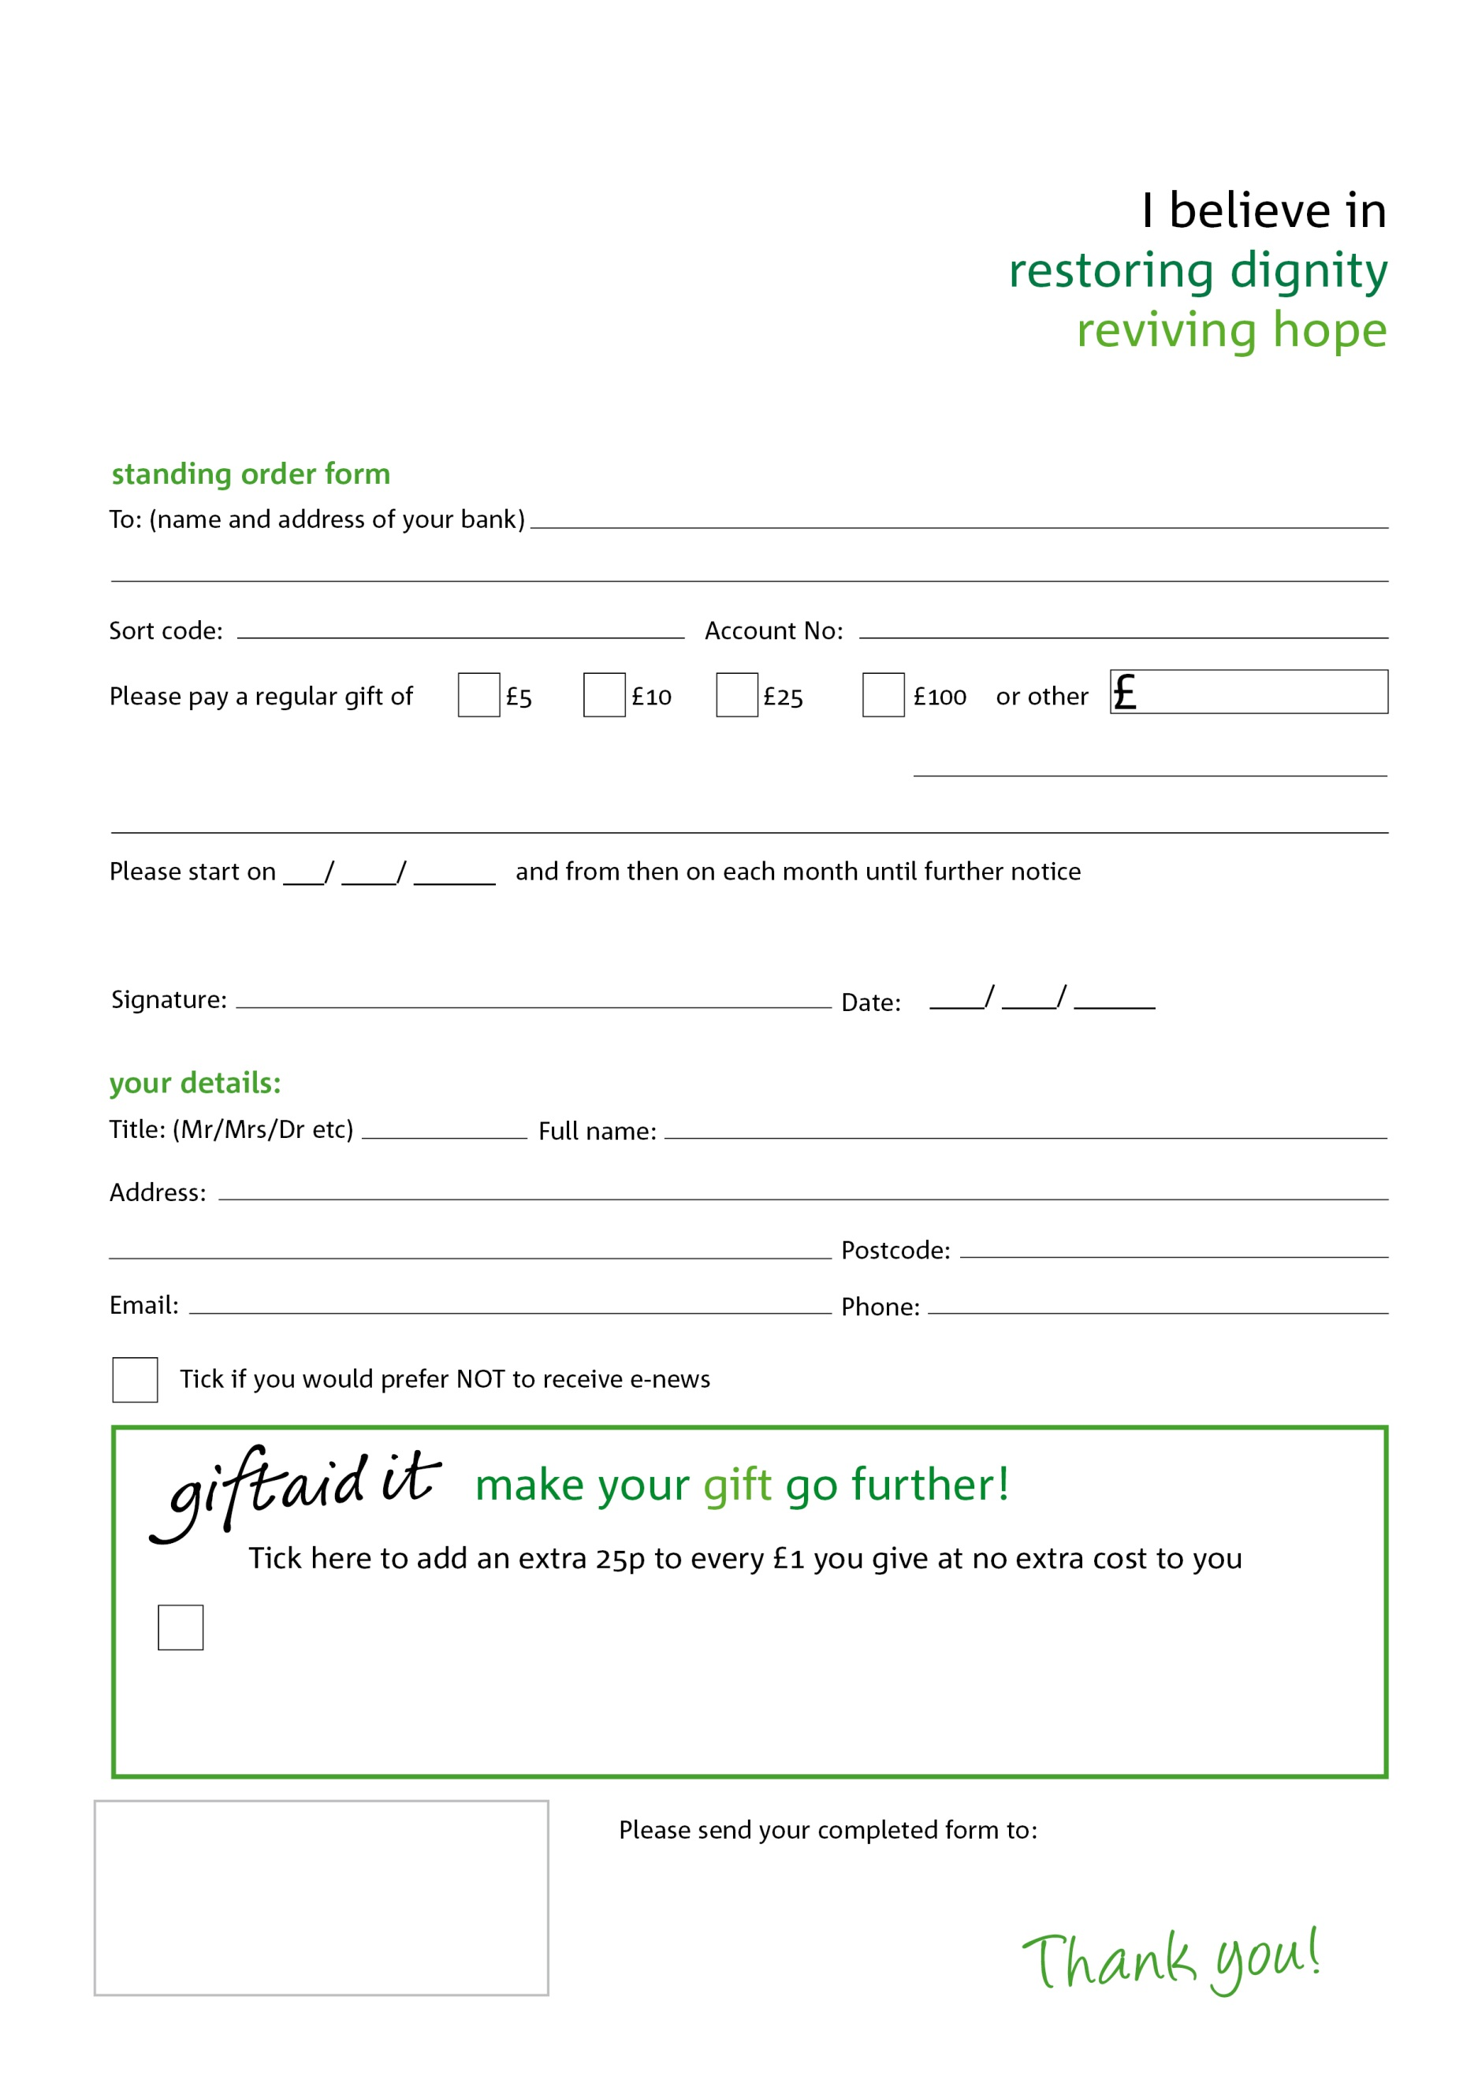­

Registered Charity in Scotland No: SCO44944

to Edinburgh NE foodbank each month,

Edinburgh NE Foodbank, 6 Henderson Street, Edinburgh,EH6 6BS

Yes, I pay tax in the UK. Please treat all donations I make or have made to Edinburgh NE foodbank for the past four years as gift aid donations until further notice.

I confirm I have paid or will pay an amount of Income Tax and/or Capital Gains Tax for each tax year (6 April to 5 April) that is at least equal to the amount of tax that all the charities or Community Amateur Sports Clubs (CASCs) that I donate to will reclaim on my gifts for that tax year. I understand that other taxes such as VAT and Council Tax do not qualify. I understand the charity will reclaim 25p of tax on every £1 that I give.

Tick if you would prefer NOT to receive e-news

This cancels any previous standing order instructions to Edinburgh NE foodbank

Edinburgh NE foodbank’s bank details: 140 High Street, Musselburgh,EH21 7DZ

Sort code 82-70-09

Account number 70039364

www.edinburghNE.foodbank.org.uk